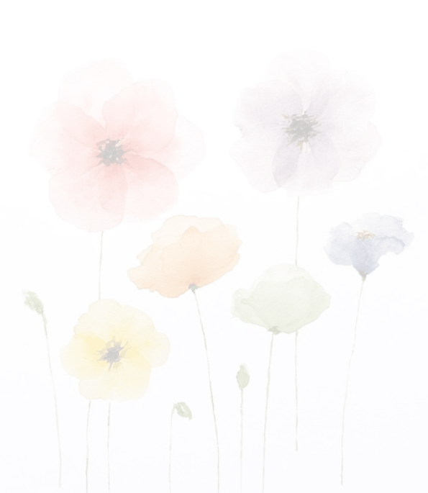

ANNUAL COLOR FOR YOU

E. Keith Worsham

Class: WDD 130-01

12/12/2023

Introduction

The “Annual Color For You” website is your go-to destination for anyone eager to play in the dirt and explore their own potential in creating and planting their own annual color beds. It is designed for individuals that a passionate for cultivating beauty. We offer expert advice with a wealth of knowledge to assist you along your journey. With the goal of empowerment so that you can transform your outdoor landscape living space into a kaleidoscope of seasonal beauty catered to your unique desires. Join us in the art of creation as you play in the dirt, build your beds, install your color and continue to maintain that beautiful garden that reflects your personal style full of blooms that bring you joy.

Should you be a seasoned horticulturalist, and expert floriculturist or new to plantings and just starting to explore the joys of having seasonal color beds around your landscape, “Annual Color For You” is the perfect site….for you.

<https://ekworsham.github.io/wdd130/seasonalcolor/index.html>

Goals/Objectives

With over 30+ years of experience in the green industry (landscape design, install, maintenance, horticulture and floriculture, and the owner of ProScapes of Atlanta), by building this website, I hope to accomplish the creation of a new and innovating training resource for not only my teams but for anyone wanting to learn more from an expert in all things landscape.

Design Process

I have had the great honor, prior to ProScapes, of working with some of the best businesses in the nation from the largest privately owned in the state to the largest publicly traded company in the nation. With both opportunities, I have been the Director of Career Development focusing primarily on creating and implementing training programs. With this experience, knowledge, resources and desire, I wanted to create something that would capture each of those elements. Plus, we just finished designing and installing our annual color for our clients. I started out wanting to include the design aspect as well (the first child page) however, the complexities and time needed to do it was greater than I had to spare. That was one big change right from the start.

Conclusion

In conclusion, while creating and completing this website project, that this is far greater than just a technical skill. It has equipped me with the beginning skills to expand upon with designing, developing and launching a live website. In addition to coding language and problem-salving techniques. I love how, and have expanded upon my creativity. Some frustrations with troubleshooting coding errors and taking html from simple info transformed through css was both challenging and rewarding. It is my hopes that as I build upon these skills and lessons learned from this class and website projects, that I too one day will be able to pursue professional opportunities within an increasingly digital world. I’ve made it to four hundred and seventy-six words and want to take a moment to thank you for your time and dedication to my success. Five hundred and four words!